Example No 01:
Input:
using System;

namespace Abdullah_Sadiq_CP_Lab_4_Remaining_Task
{
class Program
{
static void Main(string[] args)
{
Console.WriteLine("Enter the Number");
int a = Convert.ToInt32(Console.ReadLine());
if (a % 2 == 0)
{ Console.WriteLine("{0} is an Even Number", a); }
else { Console.WriteLine("{0} is an Odd Number", a); }
}
}
}
Output:
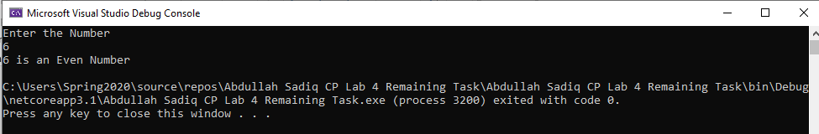
Example No 02:
Input:
using System;

namespace Abdullah_Sadiq_CP_Lab_4_Remaining_Task
{
class Program
{
static void Main(string[] args)
{
string userName = "abdullah.sadiq._";
string userNamein;
string password = "12345678";
string passwordIn;
Console.WriteLine("Instagram Login");
Console.WriteLine("Enter UserName");
userNamein = Console.ReadLine();
Console.WriteLine("Enter Password");
passwordIn = Console.ReadLine();
if (userName == userNamein && password == passwordIn)
{ Console.WriteLine("Login Complete"); }
else { Console.WriteLine("Invalid Username and Password"); }
}
}
}
Output:
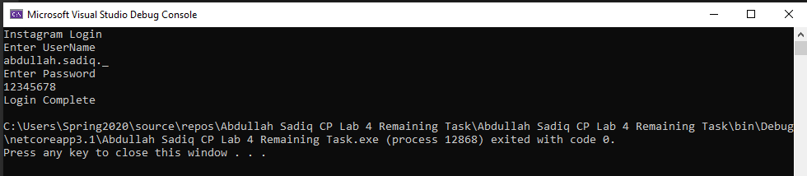

Example No 03

Input:
using System;

namespace Abdullah_Sadiq_CP_Lab_4_Remaining_Task
{
class Program
{
static void Main(string[] args)
{
Console.WriteLine("Enter Alphabet");
string alpha = Console.ReadLine();
if (alpha == "a" || alpha == "e" || alpha == "i" || alpha == "o" || alpha == "u")
{ Console.WriteLine("{0} is Vovel", alpha); }
}
}
}
Output:
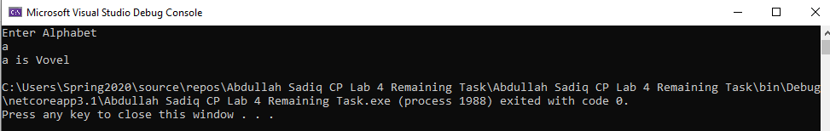

Example N0 04:
Input:
using System;

namespace Abdullah_Sadiq_CP_Lab_4_Remaining_Task
{
class Program
{
static void Main(string[] args)
{
Console.WriteLine("Enter The Number");
int num1 = Convert.ToInt32(Console.ReadLine());
string result;
result = (num1 % 2 == 0) ? "Even" : "Odd";
Console.WriteLine(result);
}
}
}
Output:
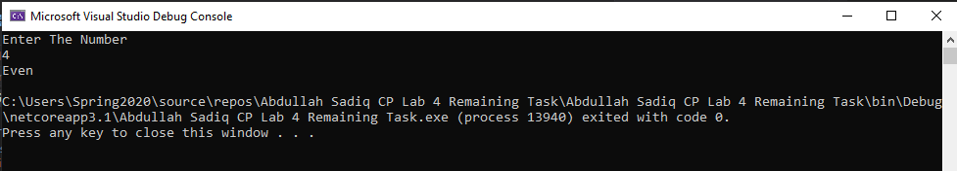

Task No 04:

Input:
using System;

namespace Abdullah_Sadiq_CP_Lab_4_Remaining_Task
{
class Program
{
static void Main(string[] args)
{
string x;
Console.WriteLine("Enter Alphabet");
x = Console.ReadLine();
switch (x)
{
case "a":
Console.WriteLine("Its a Vovel");
break;
case "e":
Console.WriteLine("Its a Vovel");
break;
case "i":
Console.WriteLine("Its a Vovel");
break;
case "o":
Console.WriteLine("Its a Vovel");
break;
case "u":
Console.WriteLine("Its a Vovel");
break;
default:
Console.WriteLine("It is a Consonent");
break;
}
}
}
}
Output:
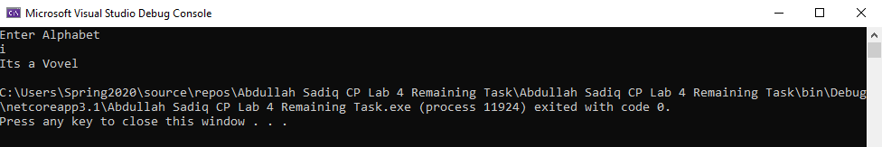

Task No 03:

Input:

using System;

namespace Abdullah_Sadiq_CP_Lab_4_Remaining_Task
{
class Program
{
static void Main(string[] args)
{
int secretNumber = 3123;
Console.WriteLine("Do you want to play, Yes or No ?");
string opt = Console.ReadLine();
if (opt == "Yes" || opt == "No") ;
{
Console.WriteLine("Enter Your Age");
int age = Convert.ToInt32(Console.ReadLine());
if (age > 5)
{

}
else
{
Console.WriteLine("Too young to Play");
}

}
}
}
}

Output:

